**Assignment – 11.3**

**Prob statement** : Write a Pig UDF To find the tweets posted by @realDonaldTrump from the given dataset. DATA SET DESCRIPTION

Column 1 : id

Column 2 : handle

Column 3 : text

Column 4 : is_retweet

Column 5 : original_author

Column 6 : time

Column 7 : in_reply_to_screen_name

Column 8 : in_reply_to_status_id

Column 9 : in_reply_to_user_id

Column 10 : is_quote_status

Column 11 : lang

Column 12 : retweet_count

Column 13 : favorite_count

Column 14 : Longitude

Column 15 : Latitude

Column 16 : Place_id

Column 17 : Place_full_name

Column 18 : Place_name

Column 19 : Place_type

Column 20 : Place_country_code

Column 21 : Place_country

Column 22 : Place_contained_within

Column 23 : Place_attributes

Column 24 : Place_bounding_box

Column 25 : Source_url

Column 26 : Truncated

Udf code :

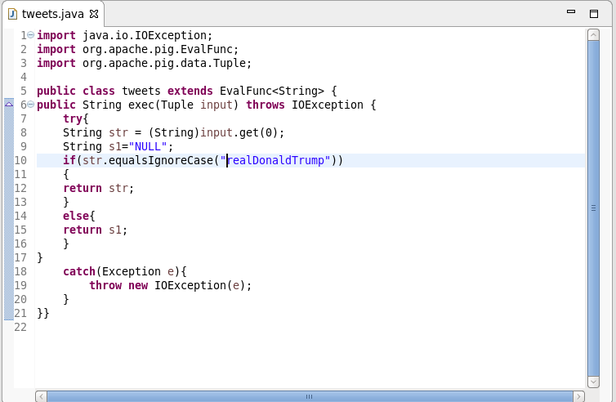

Pig code :

REGISTER ‘/home/acadgild/Desktop/udf.jar’;

DEFINE tweets tweets();

A = LOAD ‘tweets.csv’ USING PigStorage (‘,’) AS (id:chararray,handle:chararray,text:chararray,is_retweet:chararray,original_author:chararray,time:chararray, in_reply_to_screen_name:chararray,in_reply_to_status_id:chararray, in_reply_to_user_id:chararray , is_quote_status:chararray,lang:chararray, retweet_count:chararray,favorite_count:chararray,Longitude:chararray,Latitude:chararray, Place_id:chararray, Place_full_name:chararray, Place_name:chararray, Place_type:chararray, Place_country_code:chararray, Place_country:chararray,Place_contained_within:chararray, Place_attributes:chararray, Place_bounding_box:chararray, Source_url:chararray, Truncated:chararray;

B = FOREACH A GENERATE handle;

C = FILTER B BY handle IS NOT NULL;

D = FOREACH C GENERATE tweets(handle) as handle1;

E = FILTER D by handle1 IS NOT NULL;

F = GROUP E by handle1;

G = FOREACH F GENERATE COUNT(E.handle1);

DUMP G;

OUTPUT :

